**Requirements Specification**

**HofSwap Application**

**Members:**

* Trey Jean-Baptiste
* Parhum Ebrahimian
* Frank Martin
* Aishik Mallick
* Joseph Gentile

**Table of Contents**

Overview_____________________________________________________3

Authentication Pages____________________________________________5

Profile View___________________________________________________7

Textbook Upload View__________________________________________8

Textbook Search View__________________________________________9

Textbook Detail View__________________________________________10

Purchase Request and Contact Form_______________________________11

Textbook Database_____________________________________________11

Amazon Affiliate Program_______________________________________12

**Overall Objective of the Software**

The software being developed is an application designed for the use case of creating a user base that can buy and sell textbooks to/from each other. The scope of the project’s users will be limited to students who attend Hofstra University and have a valid Hofstra ID number, which they can use to sign up for an account. The application will be targeted at mobile devices and support multiple platforms, including IOS and Android. Users of the application will be able to upload their textbooks for sale to other students, or search through the textbooks that have been uploaded by other users. Sales will not be handled directly within the application. Instead, users interested in purchasing a book will request the email of the seller. When the seller accepts, the app will send each user’s email to the other.

**Selling a Textbook**

On their profile page, a user can see their various listings in a horizontal row. This row can be scrolled through. There will be an image of the book that they are selling. Below the image will be the title of the book, the author, the condition, the price, and the ISBN number. On the upper-left corner of each image will be a small circular red button with a minus sign. Tapping this will bring up a popup in the middle of the screen asking the user if they want to remove the listing. This popup will include the options “Cancel” on the left and “Ok” on the right. Tapping either button should close the popup. Additionally, tapping on the “Ok” button should immediately connect to the database and remove the listing. The listing for that textbook will no longer be visible on the user’s profile page.

The button to add a new listing will be a plus symbol on the bottom middle of the user profile page. Tapping on this button will bring the user to the listing creation page. The top left-hand corner of the listing creation page will have a red arrow facing right. This button will cancel the listing and bring the user back to their profile page. The listing creation page will include several labeled text fields. The top-most one is the field to enter the title of the book. Below that will be a box to enter the ISBN number, another for the condition, and a fourth for the price that they want to sell it at. Other information like the author, an image of the textbook, and the description will be obtained from Amazon. The “Confirm” button on the top right will upload the new listing to the database and bring the user back to their profile page, where they can see the new textbook listing added to the list. Other users should then also be able to see the new listing if they search for the book.

**Buying a Textbook**

In the bottom right corner of the user’s profile page there will be a button with a magnifying glass and will link the Textbook Search Page. On this page, the user can look up a textbook using its name or ISBN number. This search will return a vertical list of links representing every copy of the looked-up textbook in the database. Each link will navigate to the Detail View corresponding to that textbook. The Detail View will display information on the textbook from Amazon such as a picture of the book’s cover, the author, and a description of the book. Near the bottom middle of this page, a large “Purchase” button will allow the user to request the book for purchase from the seller. Once pressed, a prompt will confirm to the user that their request will successful.

**Requirements**

1. Authentication Pages

Allows user to enter their credentials to either gain access to their account or create a new account. There are two pages total, the Sign-In View and the Sign-Up View. Both contain links to the Profile View.

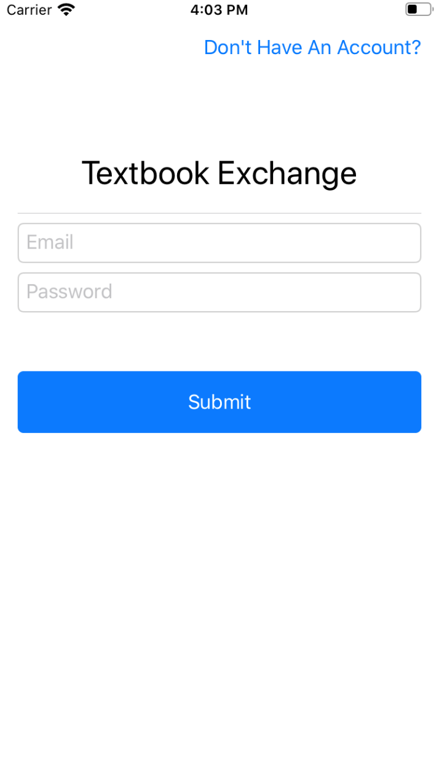1.1 Authentication Pages – Sign-In View

Users will be prompted to enter their email and password into two text fields. A “Sign-In” button under them will attempt to sign in the user with the given credentials. If this is successful, the user will be brought to their Profile View. If not, the user will be prompted to reenter their credentials and try to sign in again.

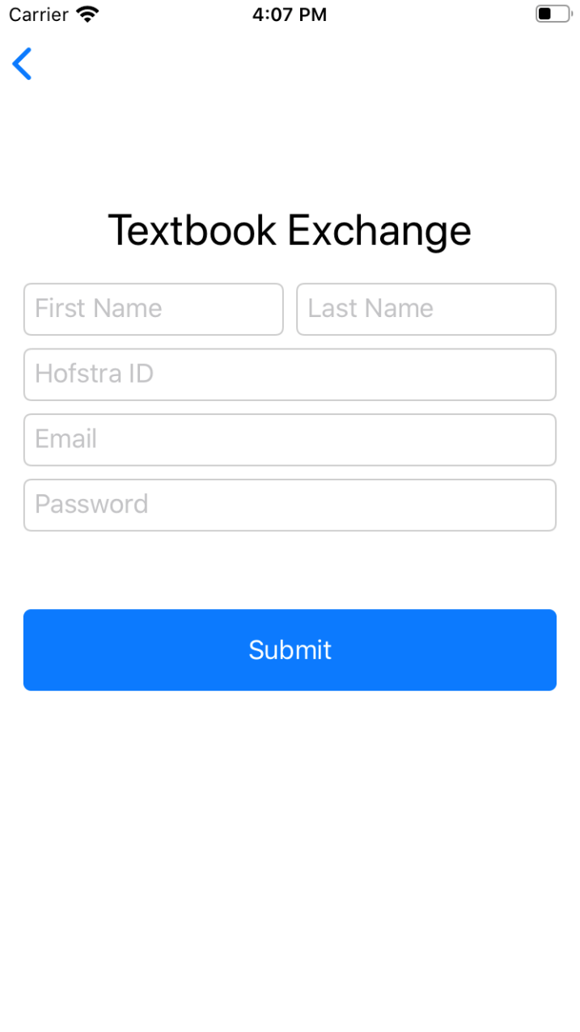1.2 Authentication Pages – Sign-Up View

Users will be prompted to enter their name (first and last), Hofstra id number, email and password into five text fields. A “Sign-Up” button under them will attempt to sign up the user with the given credentials. If this is successful, the user will be brought to their Profile View. If not, the user will be prompted to reenter their credentials and try to sign up again.

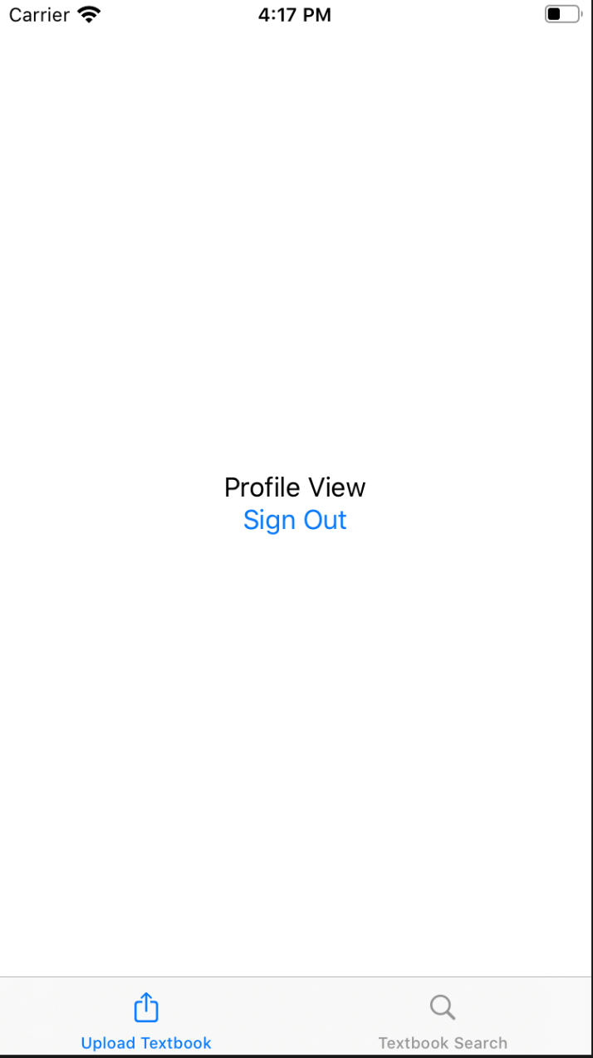2. Profile View

After signing up/in to their accounts, users will be brought to their Profile View where their information is displayed. The top of the page will display the user’s name and Hofstra id. The bottom of the page has links to the Textbook Upload View and the Textbook Search View.

The user will also be able to see all of the textbooks they have uploaded and delete them if they are no longer available.

2.1 List of the user’s textbooks

Users will be able to see all of their textbooks on their profile page. This list of textbooks will be able to be scrolled horizontally. Next to each textbook will be a button to remove the book from the application.

2.2 Interactive buttons

Buttons at the bottom of the page will be used to begin the process of uploading a textbook, ad well as searching for a textbook. These will bring users to separate pages to access these features.

3. Textbook Upload View

When a user has a textbook that they are ready to sell, they can upload it to the app using the Textbook Upload View. User’s will enter the book’s ISBN number, the price they would like to sell it for, and the condition of the book. After hitting the “Submit” button below the text fields, the user will get an email confirming that they uploaded their textbook successfully.

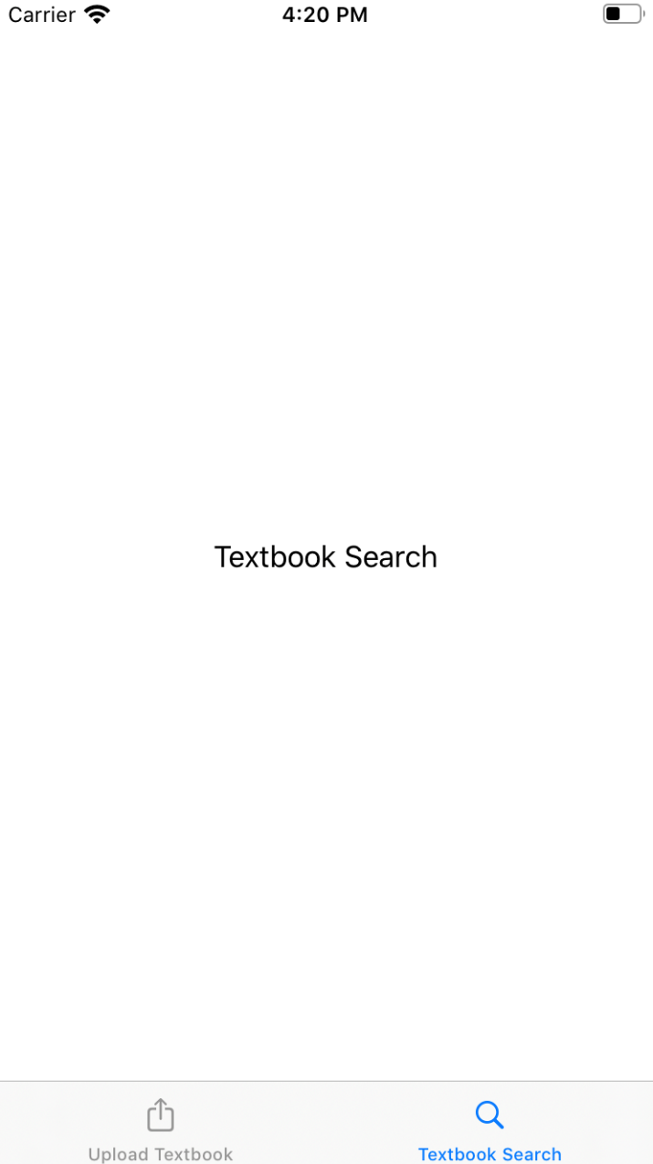4. Textbook Search View

The Textbook Search View allows users to look up textbooks that they want to buy and request them from the seller. A search bar will be located at the top of the profile page that allows users to enter the title, author, or ISBN number of the book they are looking for using an on-screen keyboard. This will bring up a vertical list of the textbook listings from various other users that match their search. The list will be organized from lowest price to highest price and able to be scrolled through. Each listing will contain the books name, author and ISBN number. Tapping anywhere on the listing should bring the user to a detailed view page for the item.

4.1 Search bar

At the top of the page is a search bad which can be used to search for a book using its title or ISBN number.

4.2 List view of books

After searching for a book, textbooks will be listed in order to increasing price. This list will be vertically scrollable by the user to see more textbooks.

5. Textbook Detail View

After clicking on a listing in the Textbook Search View, the user will be brought to the Textbook Detail View. On this page the user can find more information about their book, such as a picture of the cover and a description of the book provided by the Amazon Affiliate Program. Near the

bottom of this page there is a “Contact” button where the user can use to make a purchase

request and use the Contact Form.

5.1 Textbook Image

The detail view of each textbook will include an image of the cover. This image will be supplied by the Amazon Affiliate Program.

5.2 Textbook Information

Information listed about each textbook will include the title, author, and ISBN number entered by the user who uploaded the book. A description of the book will be presented from the Amazon Affiliate Program.

6. Purchase Request and Contact Form View

Once the user hits the purchase button, they will be brought to the Contact Form View. Here, they can send a message to the seller over email with their name, email, and any other information they would like to include. The seller then has the opportunity to reply to this email with their contact information.

7. Textbook Database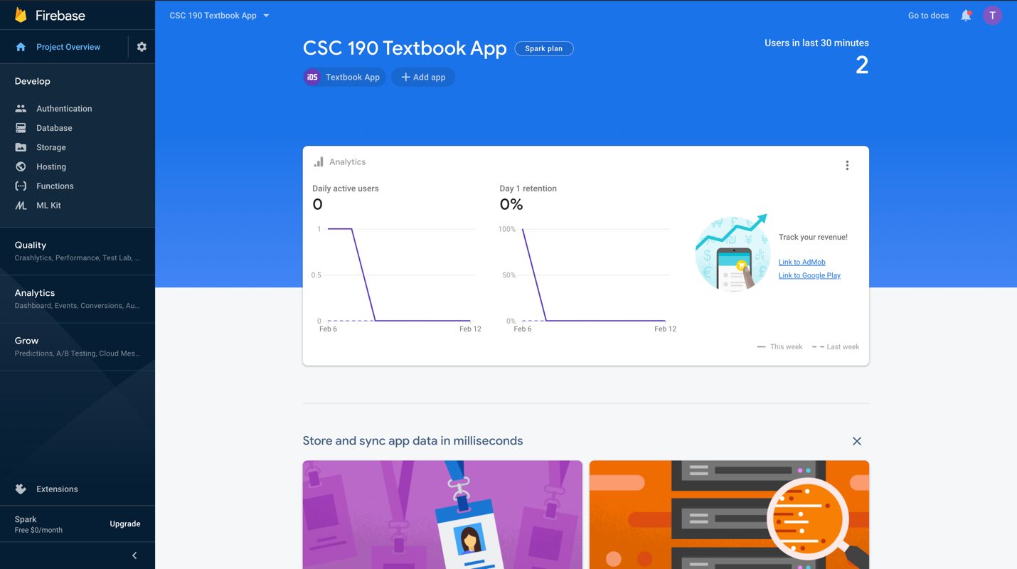

Our databases for user authentication and textbook information will be provided by Firebase. Firebase is a mobile and web application development platform developed by Firebase, Inc. in 2011, then acquired by Google in 2014. This will allow us to focus on the front end and other functionality of our app since no one in our group have experience with database design.

8. Amazon Affiliate Program

Most of the information on our textbooks won’t be stored in the databases, but instead will be acquired from the amazon affiliate program. This information is similar, if not identical, for most textbooks.